Antonio Pisani
→ ted talk paolo benati

Human evolution and observation of animal behavior
Human evolution passes through the observation of animals. We know a lot by observing animals. We can also study the observation of movement of small animals or even molecules.

We can do experiments with good feedback but without big effort. We can study for example rodents or primates.

Now research with primates is getting harder (EU laws) and animals in general.
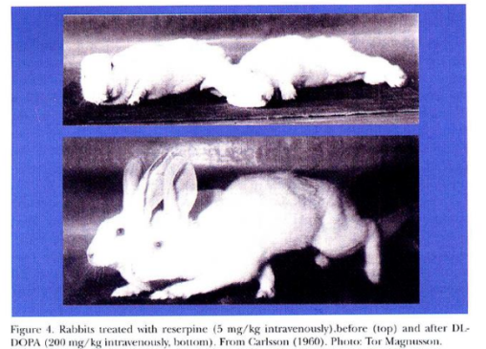
Study of dopamine in human behavior. Parkinson's patients have neurons that produce dopamine dies. Dopamine is a neurotransmitter that is lacking in Parkinson disease. Carlossn experimented in the 1950 with rabbits. Rabbits injected with drugs (called reserpine) that remove dopamine, they got rabbits unable to do anything (can not move). After an injection of dopamine they start to move back.

Study of human motor system
To get in the motor system we should be aware of anatomy (voluntary or involuntary movements). Also there is a motor development that passes through motor learning. Motor learning is learn a sequence of movements that are very precise and sharp. Can learn much more easily during development. Both athletes and musicians have a much better outcome when they start very early.
a subject of study in neuroscience laboratories.

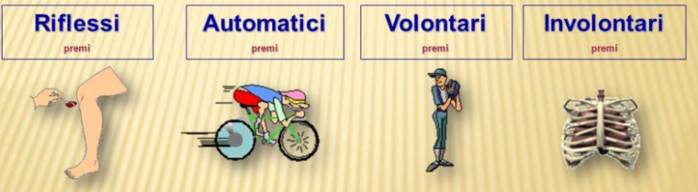
There are different types of movements such as
- Simple reflex: like the movement of the leg when hitted
- Automatic movement: like riding a bike, if you do not use a bike for 20 years you still know how to do it, you just need to remember the movements.
- Voluntary movement: learn a sequence of movements that are very precise and sharp. It is much easier to learn movements when younger. Musicians and athletes have better performances if they learn to do it during development.
- Involuntary movements: like for respiration, cardiac activity, bowel functions

Nervous systems
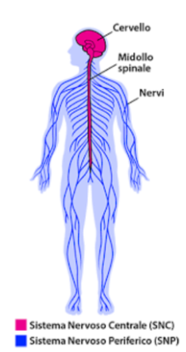
Central nervous system, made of
- Brain: enclosed in the skull, is in direct continuity with the spinal cord
- Spinal cord

Peripheral nervous system → All the nerves get out of the spinal cord and then spread in distant part of the body.

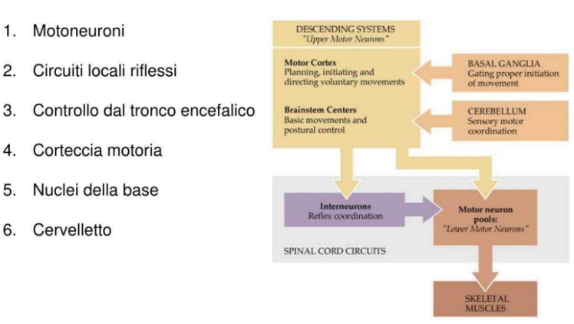
There is a very complex integration of systems that integrate each other to produce a movement.

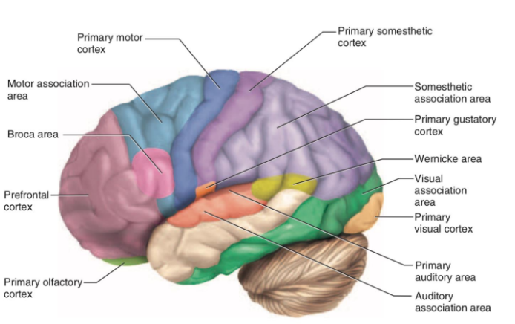
There is the motor cortex which subserves different functions and it’is divided into lobes.

Frontal lobe
In front of the sulcus there is a pre-sulcus area (in blue) and it is the primary motor cortex.

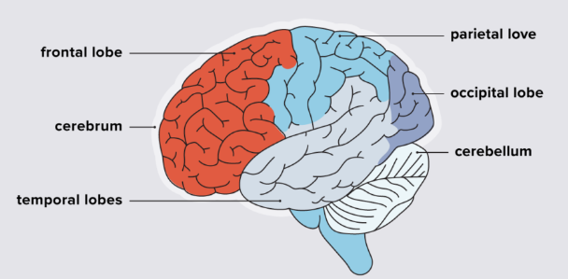
Brain is like mountains, because in this way it is bigger, higher efficiency in terms of space.

Frontal lobe: is a region of the hemisphere and is in the frontal part of the head, anterior to the central sulcus. The precentral gyrus is the primary motor cortex where all the commands are set for a given movement. The area of the frontal lobe anterior to the precentral sulcus is divided into the superior, middle and inferior frontal gyri.

When you have an epilepsy seizure there is an abnormal spike activity, you have a domino effect on the cells that results in seizure.
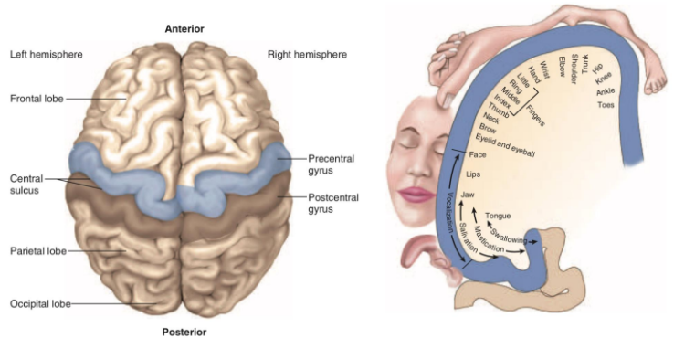

The main central system is called the scissura centrale (central sulcus). It divides the two hemispheres (left from right) and it’s connected to a number of areas that are connection areas such as the corpus callosum.

Motor homunculus: drawn so that body parts are in proportion to the amount of primary motor cortex dedicated to their control.

If we look at the brain from above we can see the sulcus.

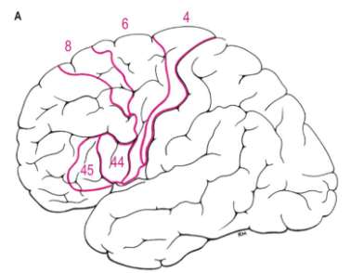

- Area 4: precentral gyrus that is the primary motor cortex
- Area 6: premotor area, called supplementary motor area. Helps to control and plan movements.
- Area 8: devoted to eye movements. Frontal eye fields, the role in to control of visual attention and eye movements
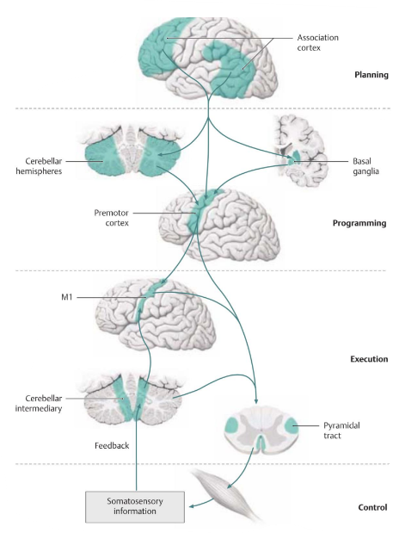

When you have voluntary movement you do not use only the motor or premotor context. The first step is in the association cortex (where the movement is planned)

After that you have cerebellar and basal ganglia that have a filter function, helping selecting desired movement.

Then the premotor cortex passes the information to the motor cortex (area 4) then releases the information to be sent out. This is grossly what happens when we decide to do a movement.

As an example when I want to close the door or when I want to run on the sand I have to take into account possible obstacles (like hitting something or the surface of the beach that is not regular). Decision and execution take milliseconds.

Motor pathways
The motor system is the part of the central nervous system that is involved with movement.

Two major motor system
- Pyramidal tracts/system (Frecciarossa, go fast and don’t stop): begins in shape like piramides cells. It is a disyanptic pathways. It’s a very simple system. There is the first neuron in the motor cortex, and then it goes downs to its axones and reaches the spinal cord and in the spinal cord the synapse is made with second motor neuron. From here the second motor neuron sends the signal to the muscles. If you don’t have these two neurons no movement is possible.
- Extrapyramidal tracts/system (Regionale, stops at every station): it is more complex than the pyramidal tract. It originates in the brain stem and carries motor fibers to the spinal cord. Are responsible for the involuntary and automatic control of all musculature, such as muscle tone, balance, posture and locomotion. Several synapses within the brain and these are called relay stations. Is it longer and when they get to a given area and that area says you can go and proceed further to the next station.

Pyramidal tracts
NOTE: pyramidal tracts are named since they traverse through the pyramids of the medulla

The pyramidal tract has two main components:
- Corticospinal tract: transmit impulses from the brain to the cranial nerves. Involved in controlling facial expressions, swallowing, mastication and related functions
- Corticobulbar tracts: transmit impulses from the brain to the spinal cord, which controls the voluntary movements

From there the motor neurons send the signal to the muscle.
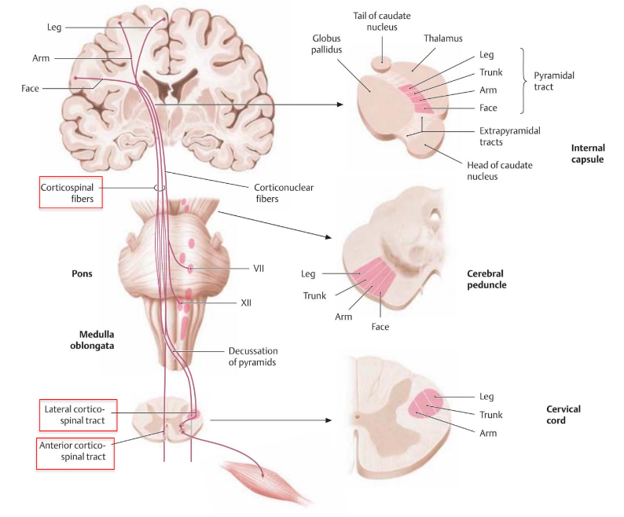
Pyramidal changes direction, and then proceeds on the spinal cord.

If you have a stroke (block support of blood) in the left part you get opposite side of the body problems. There is a change.
Spinal cord lesion does not cross again (so both side).

Without first and second motor movements people are unable to do movements but they are conscious.

- Grey matter: made of nuclear matter and soma
- White matter: made of axons, named white because axons are covered with myelin which is white.

Corticonuclear fibres: you get the intervention of cranial nerves. 12 pairs of cranial nerves that help us for all the functions of our face and what is related to the face such as smiling, chewing, swallowing etc. We have three cranial nerves out of 12 that are required for eye movements. (3rd, 4th and 6th).
Hypoglossal nerves just move the tongue.
Vagus is not only a cranial nerve, because it is involved in respiratory and muscle activity.

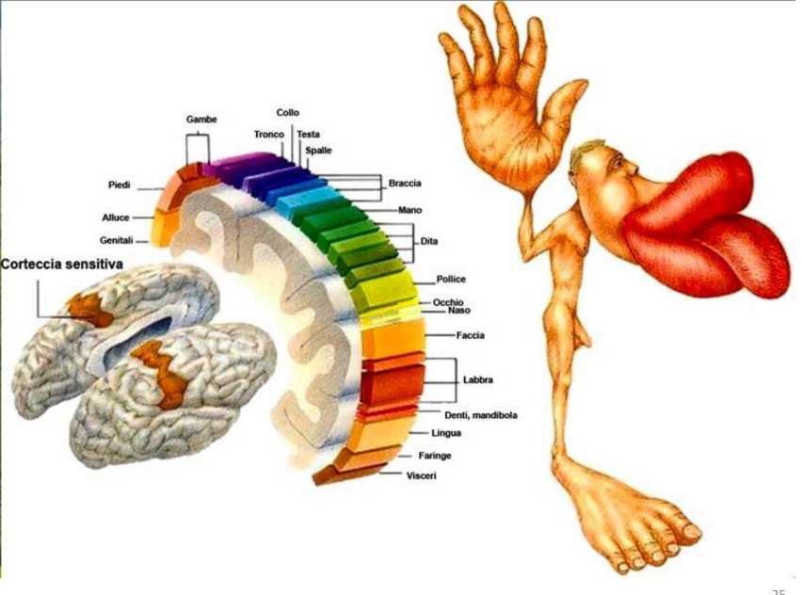
Motor homunculus shows the portions that are evolutionary meaningful and others less important. Representation is different in other species. According to what is needed to survive, the brain changes the representation. Also the representation is totally different from other animals.

Motor homunculus suggests that:
- Brain regions involved in fine movements are more represented: primates do not have the abduction of the thumb
- The area extension is proportional to the muscle region involved.
- The surface of the area is proportional to its use.

How the body is represented in the brain ⟹ Study done by Penfield.
Brain itself has no pain termination so you can touch the brain it and it does not hurt ⟹ local anaesthesia most for the skull. Penfield used to touch the brain to find out to which area each part of the brain belongs.

Extrapyramidal tracts

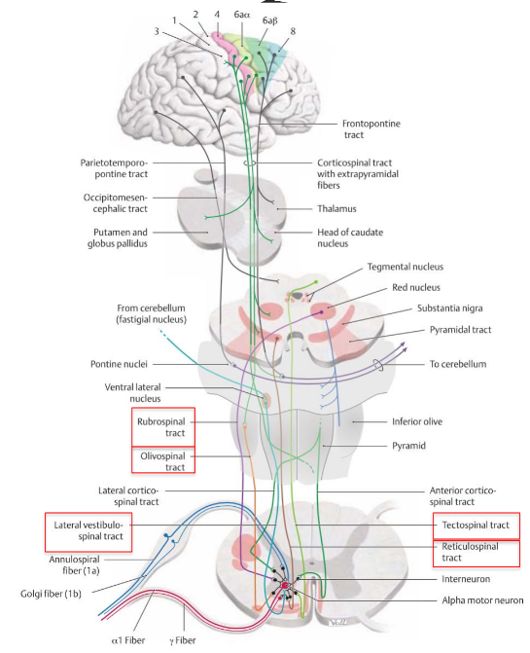
The extrapyramidal system controls larger muscles, which are responsible for maintaining posture and locomotion. The motor pathways in the extrapyramidal system have synapses within the brain and do not run within the pyramids of the medulla oblongata.

There are several pathways, synaptic pathways.
Combination of these pathways. The most relevant are:
- Rubrospinal tract: starts in a nucleus called the red nucleus, which has the function that is still not fully understood, if you have lesions of the red nucleus there is a high amplitude tremor. It should play a role in the management of fine hand movement.
- Olivospinal tract:
- Vestibulospinal tract: There are two vestibulospinal pathways: medial and lateral. They arise from the vestibular nuclei, which receive input from the organs of balance. The tracts convey this balance information to the spinal cord, where it remains ipsilateral. Fibres in this pathway control balance and posture by innervating the ‘anti-gravity’ muscles (flexors of the arm, and extensors of the leg), via lower motor neurons.
- Reticulospinal tract: The two reticulospinal tracts have differing functions: The medial reticulospinal tract arises from the pons. It facilitates voluntary movements, and increases muscle tone. The lateral reticulospinal tract arises from the medulla. It inhibits voluntary movements, and reduces muscle tone.
- Tectospinal tract: This pathway begins at the superior colliculus of the midbrain. The superior colliculus is a structure that receives input from the optic nerves. The neurons then quickly decussate, and enter the spinal cord. They terminate at the cervical levels of the spinal cord. The tectospinal tract coordinates movements of the head in relation to vision stimuli. Fibres of the tract synapse with motor neurons of the cervical muscles and mediate reflex postural movements.

Extrapyramidal and pyramidal interact to the final outcome which is the correct movement.

Role of Basal Ganglia in Movements
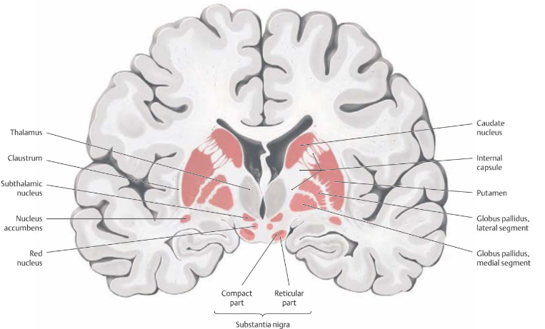
Basal ganglia: responsible for voluntary motor control, procedural learning, and eye
movement, as well as cognitive and emotional functions. The basal ganglia are principally involved in the selection and implementation of purposeful actions in response to external and internal cues.

One of the portions of the brain that helps in filtering the information is made of this multiple subcortical region that has the name of basal ganglia.

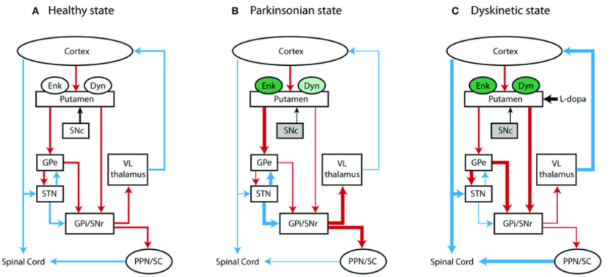
Basal ganglia loop: goes from the cortex ⟹ goes down to the main input area which is called striatum ⟹ to the thalamus and then back to the cortex. Cortex sends a message to the putamen.

It’s a chain of information progressively filtered through the basal ganglia. Action selection.
Implementation of purposeful actions in response to the external and internal clues. Fine voluntary movement.

Major basal ganglia loops are the motor, the associative and the limbic loop. All of these are associated. Thalamus has to do a great job.
the role of the basal ganglia in movements in concerned with control.

They integrate the information from the cortex, process in parallel and return the thalamus

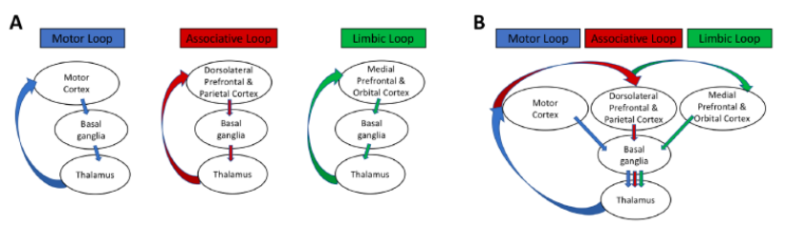
Within the basal ganglia you have subspecialists and these specialties are region dependencies. Because the cells are segregated and divided in mini-spots and are specialised.
- Motor loop
- Associative loop: association of movements and cognition
- Limbic loop: mostly involved in regulating emotions

Thalamus is not understood completely yet. They have important task to filter the last step of the information that goes back to the cortex

Cerebellum
Cooperates with basal ganglia to refine movement, stability, precision, coordination etc. But the cerebellum does not initiate movement.

It receives input from sensory systems of the spinal cord and from other parts of the brain, including the cerebral cortex, and integrates these inputs to fine-tune motor activity. Because of this fine-tuning function, damage to the cerebellum does not cause paralysis, but instead produces disorders in fine movement, equilibrium, posture, and motor learning.

Cerebellum is a very ancient part of the brain, step back from the evolutionary point of view. Structure is much simpler than the primary cortex. Major connection with the vestibular nuclei, spinal nuclei and motion cortex.
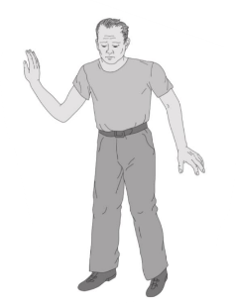
Vestibular nuclei are those that are connected for nausea and vomiting. If they get the wrong signal they will tell the brain cell to stimulate the area that stimulates the vomiting.
When you drink, how do you walk back? You need to increase the area for balance.

Analysis of movement
Can analyse it in different ways like:
- Biomechanics (Cameras, EMG, accelerometers)
- Neuroanatomy, neurophysiology (EEG, TMS, fMRI)
- Robotics

Biomechanics: you can analyse movements in different ways. We can analyse the biomechanics nature of the movement and we can set sensor or we can put needle to follow activation or inhibition to see what happens when you move

EMG: used to record activity of the cerebral cortex and depends on the action you do when the EMG is applied. EMG allows to record some movements (but it is not very precise)

